**REFUGEE APPLICATION FORM**

**Student and parent information and conditions of application**

UWC schools, colleges and programmes deliver a challenging and transformative education experience to a diverse cross section of students, inspiring them to create a more peaceful and sustainable future.

UWC has 18 schools and colleges across 5 continents, all with distinctive characters but sharing the same mission, ethos and values.

Although strong academic achievement is valued highly at UWC, academic achievements are put into perspective with a demanding mix of community engagement, international affairs, physical activities, and creative pursuits.

Our student intake is deliberately diverse and each of the schools and colleges draws together students from many different nations and backgrounds. Our bursaries, scholarships and fee structures aim to ensure a broad socio-economic mix within the student body that adds value to the student experience and the organisation.

UWC depends on the dedication and expertise of a network of volunteers to promote UWC and select future students. These are called national committees and they operate in more than 140 countries worldwide.

Each year a national committee will receive from the UWC schools and colleges a specific number of places (which may include a scholarship, bursary/partial scholarship or fee-paying place) for which they select students to study the International Baccalaureate (IB) Diploma. If a national committee exists in your country and you require a scholarship, you must apply through that committee.

**Young refugees now living in Germany can apply directly to UWC Robert Bosch College, as an application from their home countries is usually not possible. Since the foundation of the College, we have reserved at least two places for students with a refugee background and provide full scholarships along with these. For the intake of students in August 2021 one of these scholarships is provided by the RISE Foundation, which is dedicated to finding extraordinary young people who need opportunity and supporting them for life as they use their talents to serve others.** For more on the RISE initiative please see: [www.risefortheworld.org](http://www.risefortheworld.org)

Please make sure you find out as much as possible about UWC before going ahead with your application. It is important that you understand the aims of the organisation and the commitment involved in the programmes that are offered. For more information, please go to [www.uwc.org](http://www.uwc.org/)

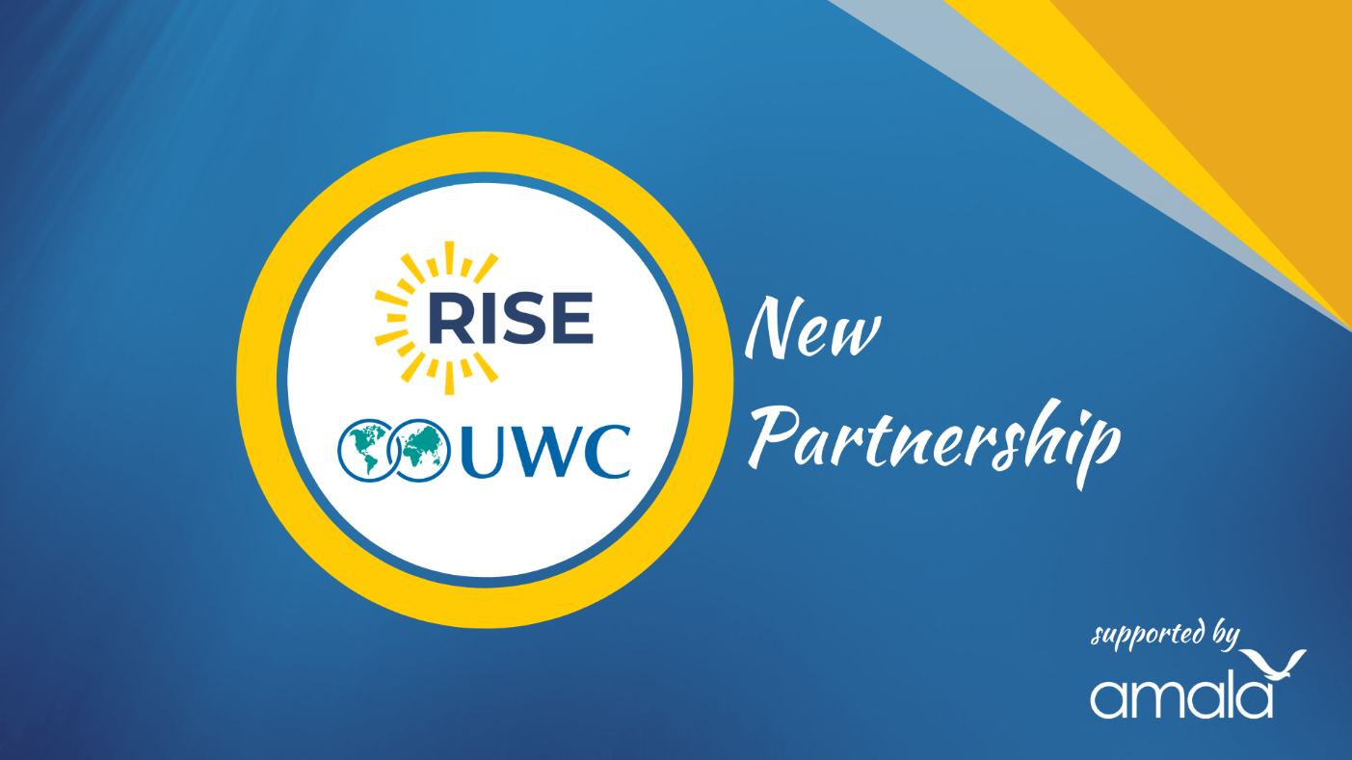

**First Round Application Deadline: January 31, 2021**

**Application materials should be submitted to: admissions@uwcrobertboschcollege.de**

**Applicant Information (Please type or write clearly in dark ink and ensure you complete all the sections that are applicable to you)**

**Personal information**

|  |  |  |  |  |  |  |  |  |  |  |  |  |
| --- | --- | --- | --- | --- | --- | --- | --- | --- | --- | --- | --- | --- |
| Family name/ Surname/ Last name: | | | | | | | |  | | | | |
| First name/ given name(s): | | | | | |  | | | | | | |
| Middle name (only if noted on passport): | | | | | | | | |  | | | |
| Gender: |  | | | | | | | | | | | |
| Date of birth (dd/mm/yyyy): | | | | | |  | | | | | | |
| Nationality: | | | | | |  | | | | | | |
| Country of Birth: | | |  | | | | | | | | | |
| Country of citizenship (on which passport would you travel): | | | | | | | | | |  | | |
| Email address: | | | | |  | | | | | | | |
| Home Phone: | | |  | | | | | | | | | |
| Cell phone: | | |  | | | | | | | | | |
| Fax: | |  |  | | | | | | | | | |
| **Permanent Home Address** | | | | | | |  | | | | | |
| Address line 1: | | |  | | | |  | | | | | |
| Address line 2: | | |  | | | | | | | | | |
| City: | | |  | | | | | | | | | |
| Province/ Territory/ Region: | | | | | |  | | | | | | |
| Post code: | | |  | | | | | | | | | |
| Country: | | |  | | | | | | | | | |
| Home Phone: | | |  | | | | | | | | | |
| Fax: | | |  | | | | | | | | | |
| **Courier Address (to receive posted mail, if different from home address)** | | | | | | | | | | | |  |
| Address line 1: | | |  |  | | | | | | | | |
| Address line 2: | | | | | | | | | | |  | |
| City: | | |  | | | | | | | | | |
| Province/ Territory/ Region: | | | | | |  | | | | | | |
| Post code: | | |  | | | | | | | | | |
| Country: | | |  | | | | | | | | | |
| Phone: | | |  | | | | | | | | | |
| Fax: | | |  | | | | | | | | | |

**School information**

|  |  |  |  |  |
| --- | --- | --- | --- | --- |
| Name of school: |  | | | |
| Address of school**:** | |  | | |
|  | | | | |
|  | | | | |
|  | | | | |
| Telephone number of school: | | | |  |
| Email address of school: | | |  | |
| Name of Head of School: | | |  | |

List the subjects that you currently study at school and your most recent grades or predicted grades:

|  |  |  |  |
| --- | --- | --- | --- |
|  |  |  |  |
|  |  |  |  |
|  |  |  |  |
|  |  |  |  |
|  |  |  |  |
|  |  |  |  |
|  |  |  |  |

Do you participate in any extra-curricular clubs or activities at school for example creative activities, sports, volunteer projects etc.? Please list up to 5 areas of involvement indicating the level and time of involvement and responsibilities.

|  |
| --- |
|  |
|  |
|  |

What are your plans after high school?

|  |
| --- |
|  |

**Life outside school**

What are your favourite activities outside of school? How do you spend your leisure time? For example, creative activities, employment, sports, volunteer projects or other hobbies. Please list up to 5 areas of involvement indicating the level and time of involvement and responsibilities.

|  |
| --- |
|  |
|  |
|  |
|  |
|  |

What do you consider your best qualities?

|  |
| --- |
|  |
|  |
|  |

What do you consider your best accomplishments?

|  |
| --- |
|  |
|  |
|  |

What language do you speak at home?

|  |
| --- |
|  |

What other languages do you speak (please list the language and the level of understanding)?

|  |
| --- |
|  |

|  |
| --- |
| How did you hear about UWC**?** |
|  |

|  |  |  |  |  |  |
| --- | --- | --- | --- | --- | --- |
| |  | | --- | | **Essay questions** | | 1. Please provide a statement (on a separate piece of paper and with a limit of 300 words) explaining why you are interested in attending a UWC school/college and reflecting on UWC’s mission and values, what you might contribute to the school/college and what you would hope to gain from the experience. | |  | | 1. Please provide a statement (on a separate piece of paper and with a limit of 300 words) describing the community in which you live and proposing a service project that could help that community.   **Additional Information**   * 1. Please provide two letters of recommendation from people who can provide further context on you. This could be from teachers, coaches, social workers, employers etc. | |  |   I have read and understood the information section at the beginning of this application form. I have discussed all aspects of the commitment involved in applying for entry to a UWC school/college with my parent(s)/guardian(s). Should the application be successful, I hereby undertake to observe the rules, regulations and guidelines of the school/college. I recognise that the school/college has the right to exclude me for violations of such rules, regulations and guidelines. |
| Signature of applicant: |
| Date: |

**To be completed by the person(s) who has legal duty of care for the student**

|  |  |  |  |  |  |  |  |
| --- | --- | --- | --- | --- | --- | --- | --- |
| **Person 1**  Relationship to student: | | | |  | | |  |
| Family name/ Surname/ Last name: | | | | |  | |  |
| First name/ given name(s): | | | |  | | |  |
| Permanent Home Address (if different from student’s) | | | | | |  |  |
| Address line 1: | |  | | | | |  |
| Address line 2: | |  | | | | |  |
| City: |  |  | | | | |  |
| Province/ Territory: | |  | | | | |  |
| Post code: | |  | | | | |  |
| Country: | |  | | | | |  |
| Home Phone: | | |  | | | |  |
| Cell phone: | |  | | | | |  |
| Fax: |  |  | | | | |  |
| Email: |  |  | | | | |  |
| **Person 2 (if applicable)**  Relationship to student: | | | |  | | |  |
| Family name/ Surname/ Last name: | | | | |  | |  |
| First name/ given name(s): | | | |  | | |  |
| Permanent Home Address (if different from student’s) | | | | | |  |  |
| Address line 1: | |  | | | | |  |
| Address line 2: | |  | | | | |  |
| City: |  |  | | | | |  |
| Province/ Territory: | |  | | | | |  |
| Post code: | |  | | | | |  |
| Country: | |  | | | | |  |
| Home Phone: | | |  | | | |  |
| Cell phone: | |  | | | | |  |
| Fax: |  |  | | | | |  |
| Email: |  |  | | | | |  |

|  |
| --- |
| **To be completed by the person who has legal duty of care for the student.**  Please give a brief description of any medical or mental health concerns, physical impairments,  serious illnesses or allergies that the applicant may have had: |
|  |
|  |
|  |
|  |
| Please list any special dietary requirements that the applicant may have for medical, religious or  ethical reasons? |
|  |
|  |

|  |
| --- |
| I  **I have read and understood the information section at the beginning of this application form and the application for entry to UWC made by my son/daughter/ward; we have discussed all aspects of the commitment involved and this application has my full approval. Should the application be successful,**  **I hereby undertake for myself and for him/her to observe the rules, regulations and guidelines of the school/college. I recognise that the school/college has the right to exclude my son/daughter/ward for violations of such rules, regulations and guidelines. While my son/daughter/ward is in residence at a**  **UWC school/college, I authorise the school /college to act ‘in loco parentis’ in decisions directly**  **effecting his/her health and welfare when it is neither possible nor practical to contact me**  **beforehand.** |
| Signature(s) of the person(s) who has legal duty of care over the applicant: |
| Date: |